*Curriculum Vitae*

*Of*

*Chanzonay Shirley Adams*

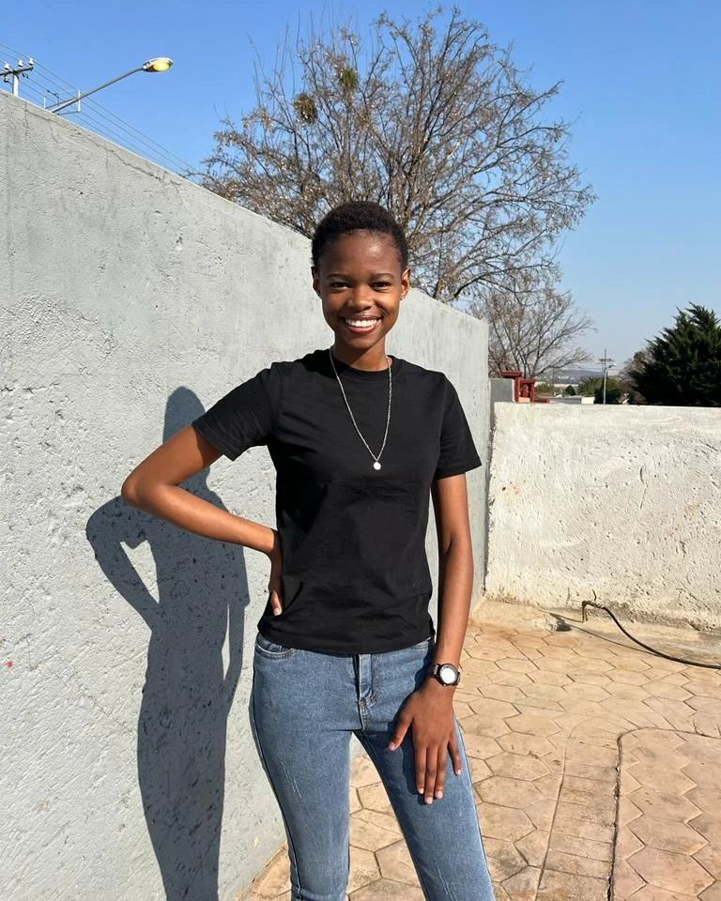

**PERSONAL DETAILS**

SURNAME : Adams

FIRST NAME : Chanzonay Shirley

GENDER : Female

DATE OF BIRTH : 04 August 2003

IDENTITY NUMBER : 0308040346089

MARITAL STATUS : Single

ADDRESS : 422 Cessna Avenue

Eersterust

0022

CONTACT DETAILS : 068 426 4660 / 061 312 6630

: Email:chanzonaya@gmail.com

NATIONALITY : South African

RACE : Coloured

LANGUAGES : Afrikaans, English, Setswana

DRIVER’S LICENSE : None

NOTICE PERIOD : None

DEPENDANT(S) : None

**EDUCATION AND SECONDARY**

HIGH SCHOOL : Prosperitus Secondary School

SUBJECTS PASSED : English

Afrikaans Mathematical Literacy

Business Studies

Geography

Computer Applications Technology

Life Orientation

YEAR : 2021

**OTHER QUALIFICATIONS**

NAME OF INSTITUTION : Interdot

QUALIFICATIONS OBTAINED : System Development NQF Level 5

SKILLS AQUIRED : Designing user interfaces and

navigation menu

Writing and reviewing code for skills

typically HTML, Visual Basic, Css

MS Office

Testing web applications

Troubleshooting problems with

Performance of user experience

Collaborating with designers,

Developers and stakeholders

**REFERANCE**

COMPANY : Interdot

CONTACT PERSON : MS Kholofelo Madisha

CONTACT NUMBERS : (w) 012 753 4187 (c) 084 515 7072

POSITION HELD : Learnership

LEARNERSHIP COMPLETED : Currently in process

RESPONSIBILITIES : Attending class

Completing assignments

